# LAB 1.1: ARP

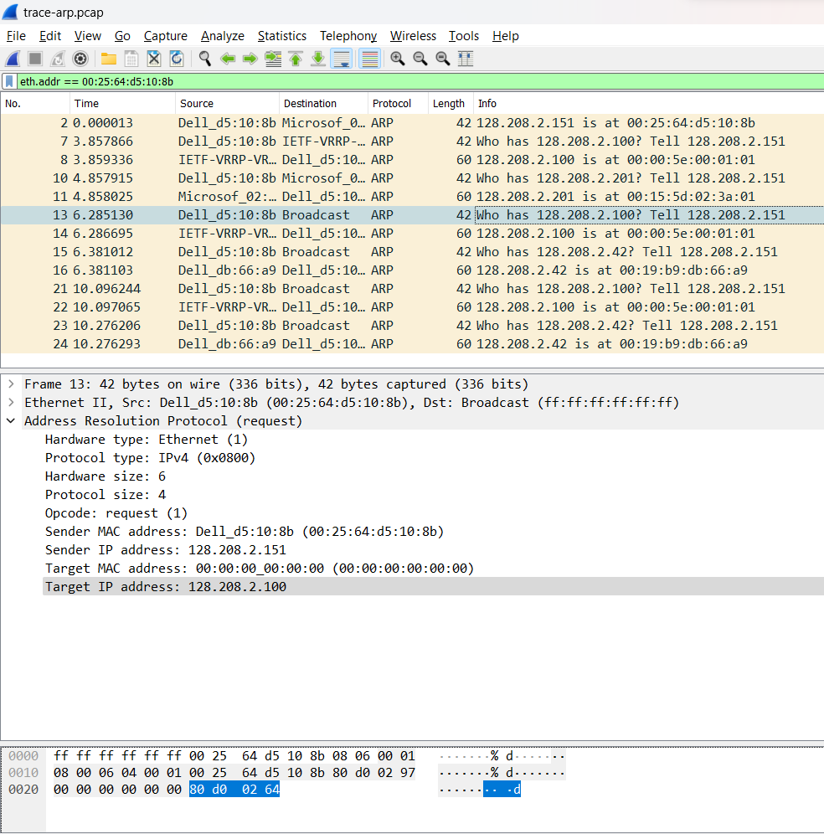

1. Opcode

* Request: 1
* Reply: 2

2. 28 byte cho cả header ARP request và reply

3. 00:00:00:00:00:00

4. 0x806

5. Không. Nó được gửi trực tiếp đến mục tiêu bằng địa chỉ Ethernet của nó.

# LAB 1.2 : PROTOCOL LAYERS

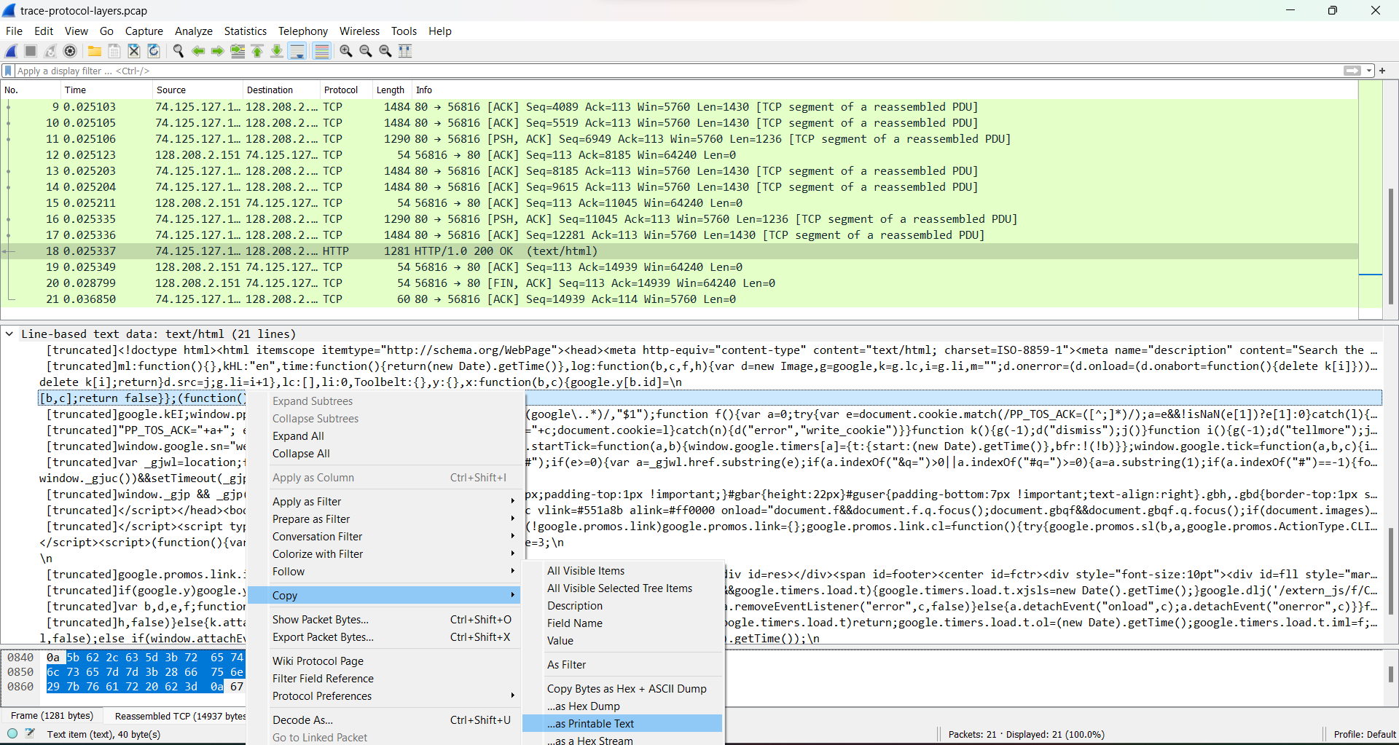

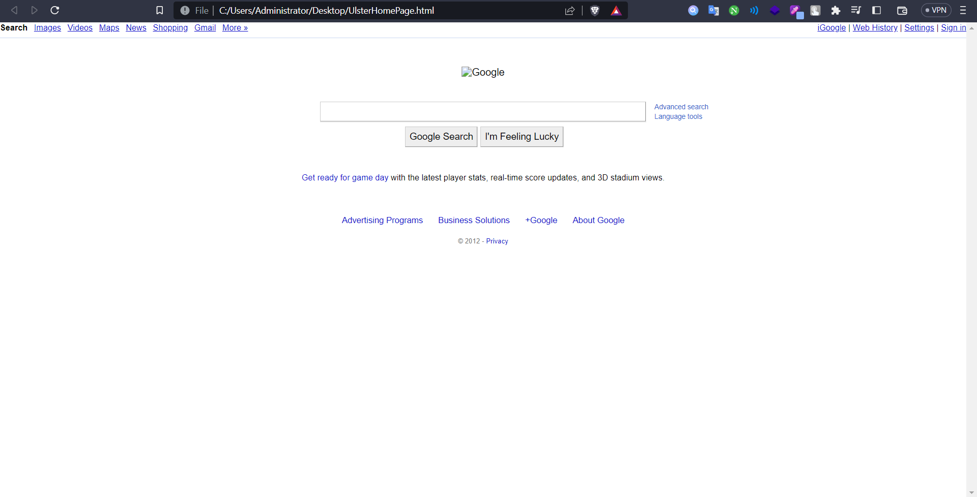

**1. Using HexView to view header about JPEG, EXE to understanding FILE HEADER**

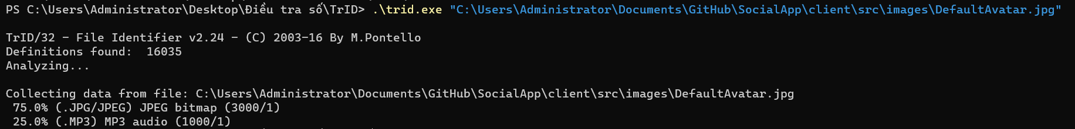

**View header JPEG by HexView**

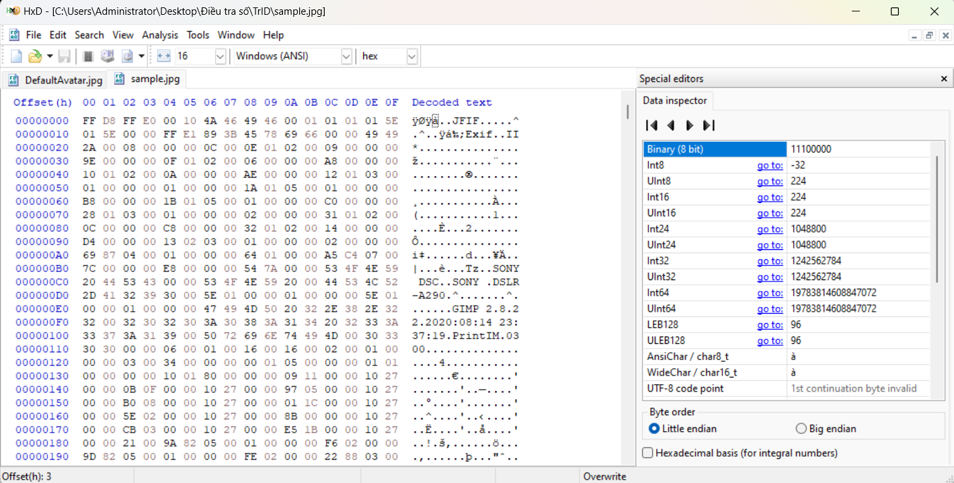

**Mofify FF-D8-FF-E0 to EE-D8-EE-E0 you can not see the picture.**



**Trid can not identify the flag file**

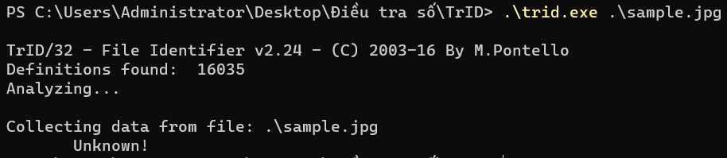

**2. Rebuilding an Image Header**

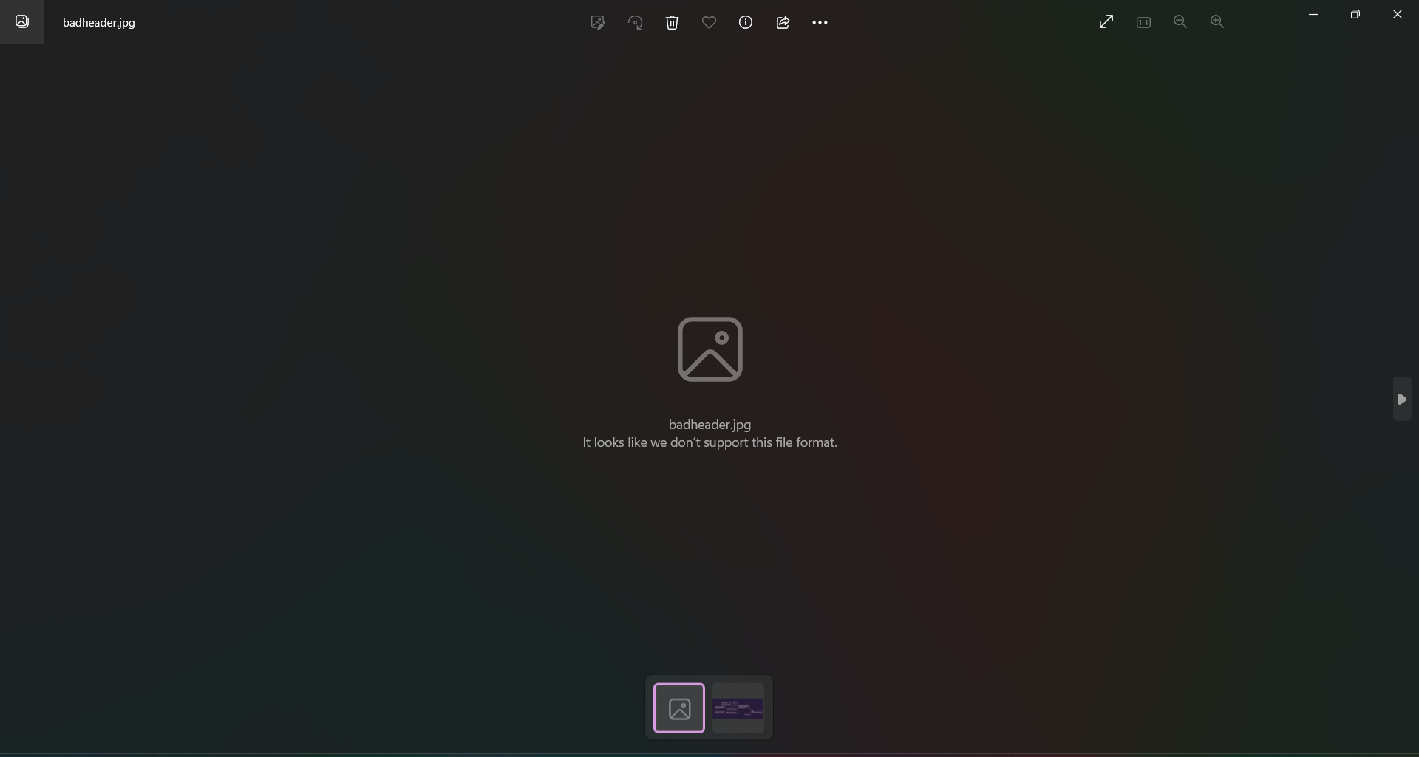

Không hiển thị được ảnh



Sau khi sửa lại header:

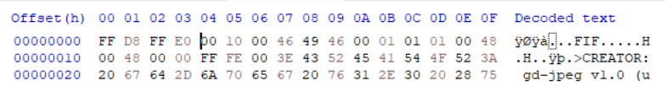

Ảnh sau khi khôi phục header:

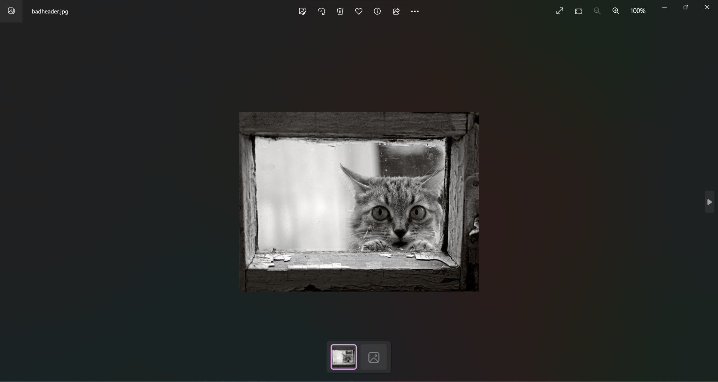

# LAB 2

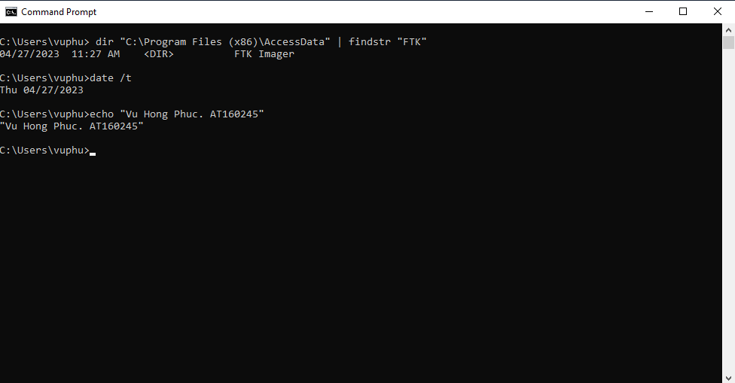

# LAB 3

**Create new Hard Disk named FTK_Test.vmdk**

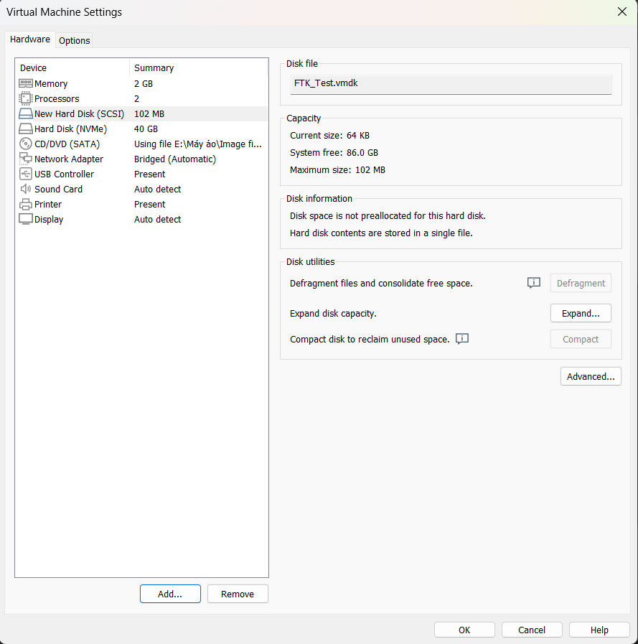

**Modify new Disk**

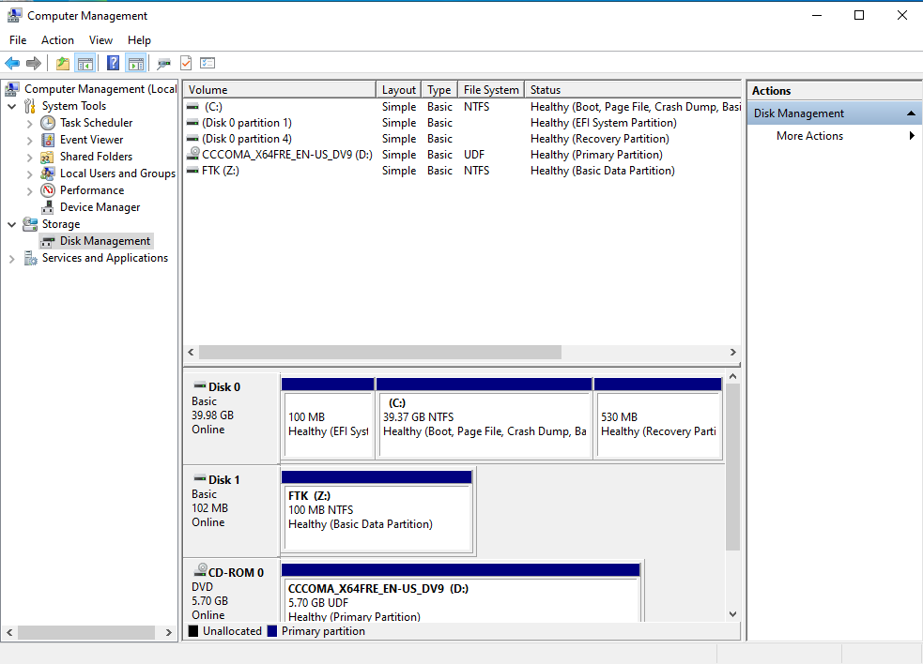

**Save Test Image in new FTK Disk.**

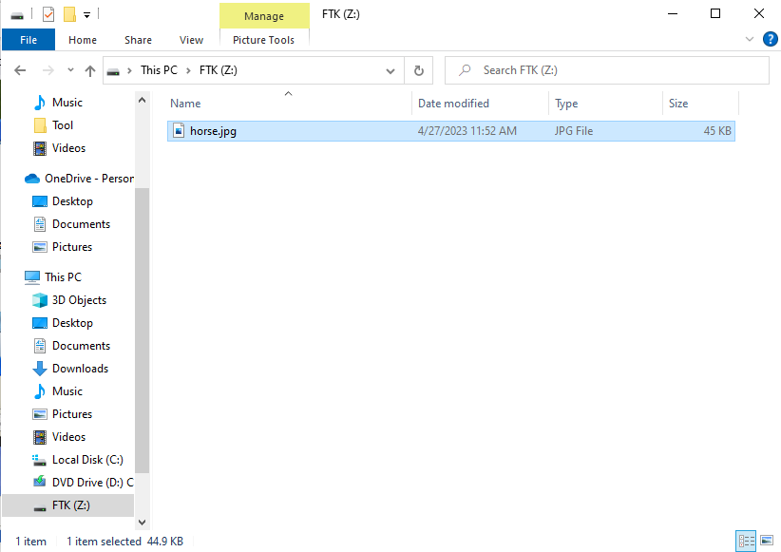

**Delete Test Image in FTK Disk and Recycle Bin**

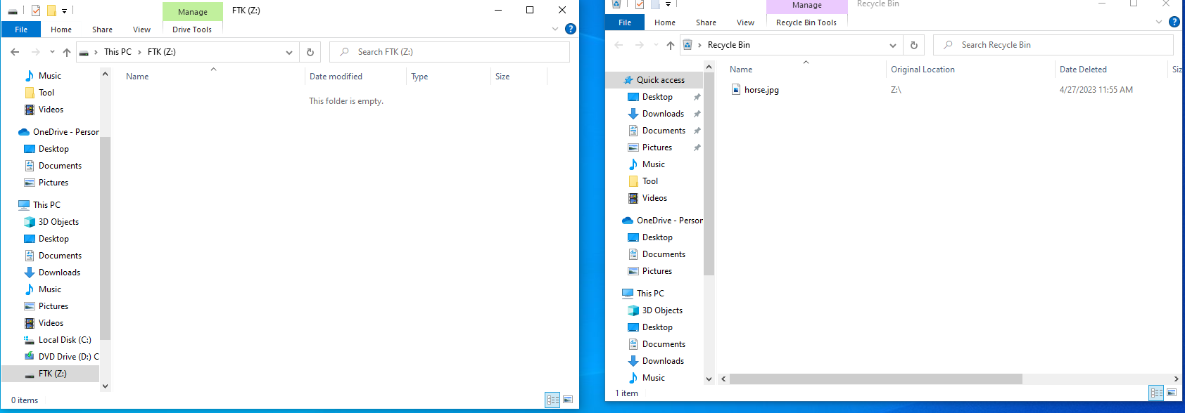

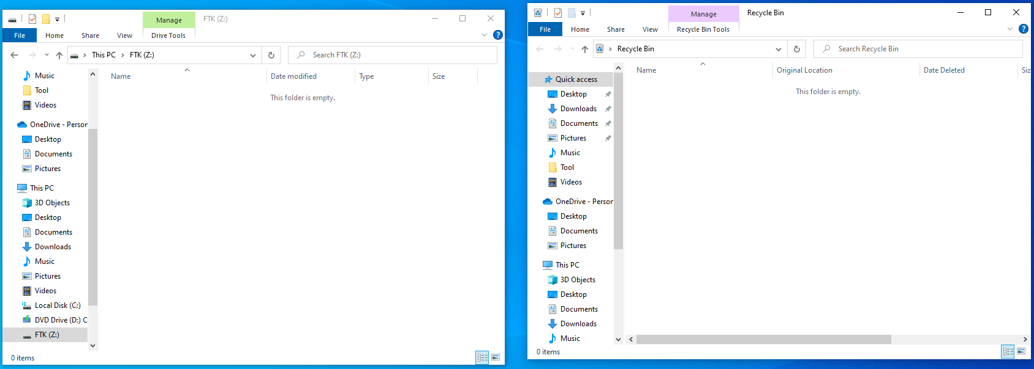

**Open FTK Imager and restore Image**

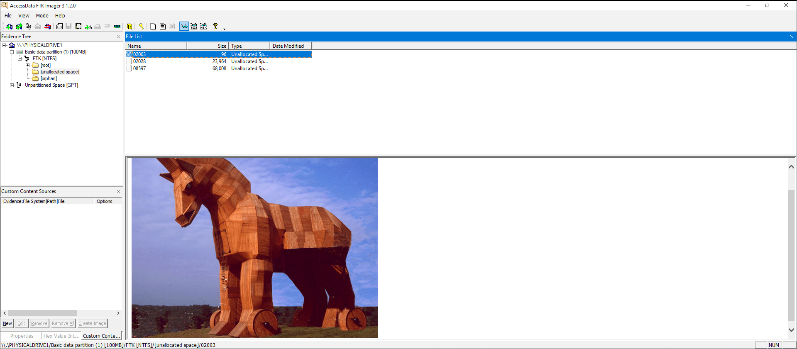

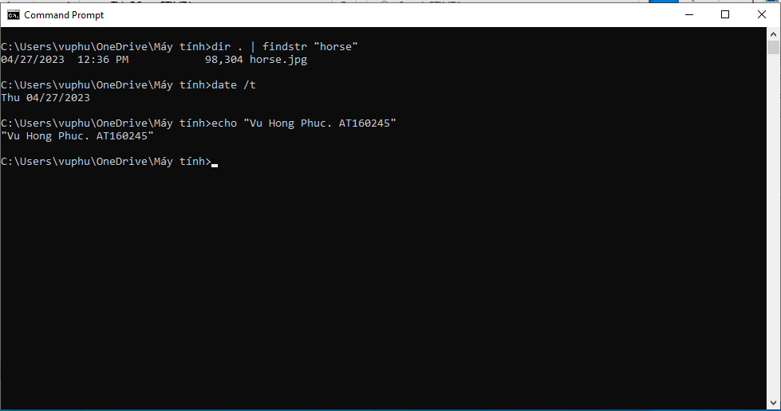

# LAB 4

**Download Image to FTK Disk**

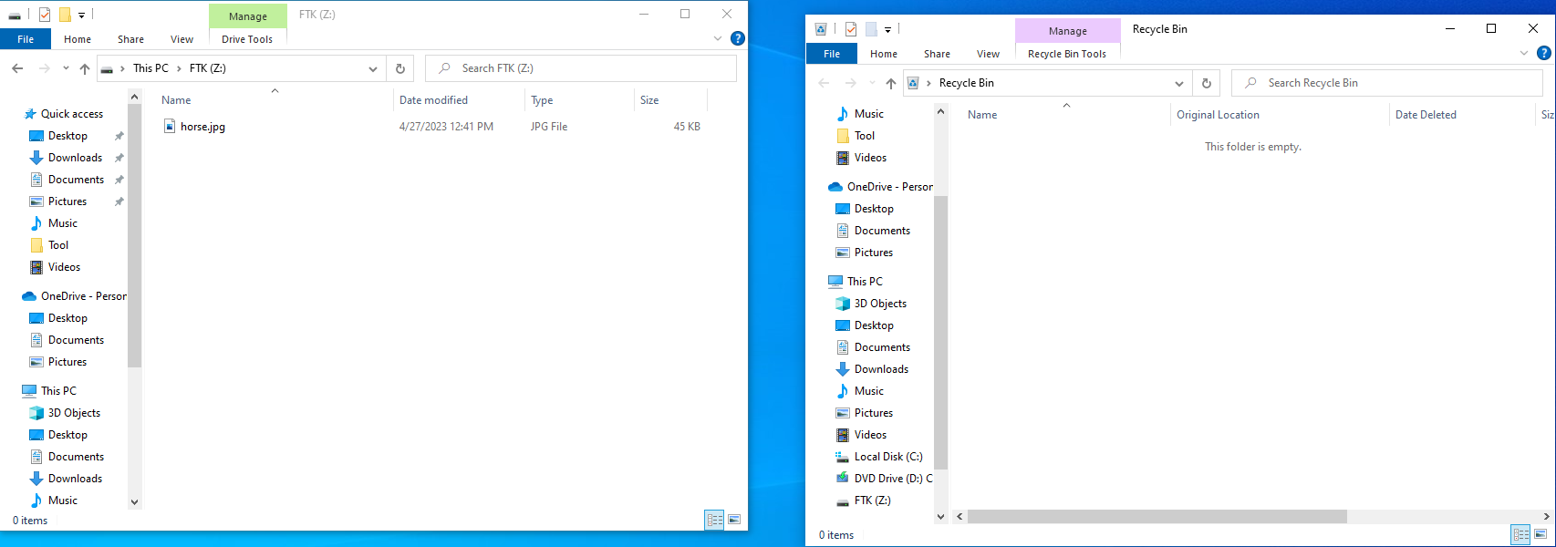

**Delete it from FTK Disk and Recycle Bin**

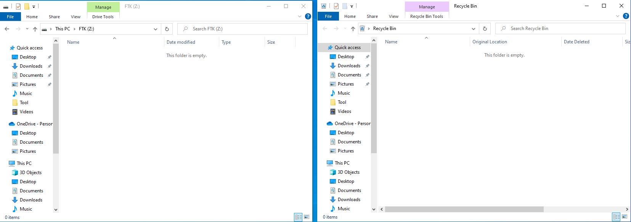

**Create new folder named Forensics on Disk C:**

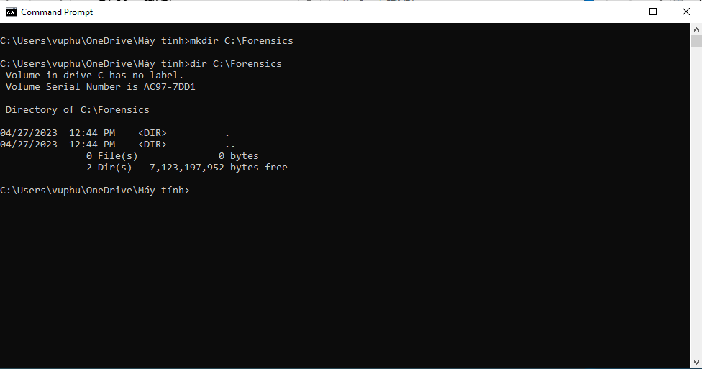

**Create Desk Image**

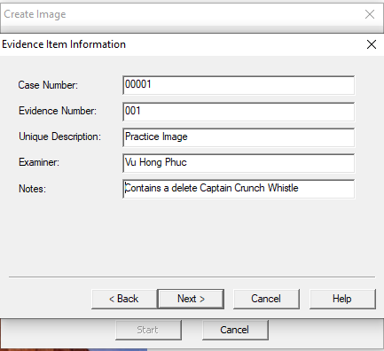

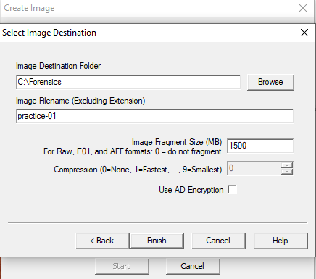

**Drive/Image Verify Results**

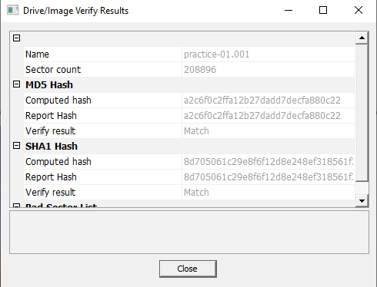

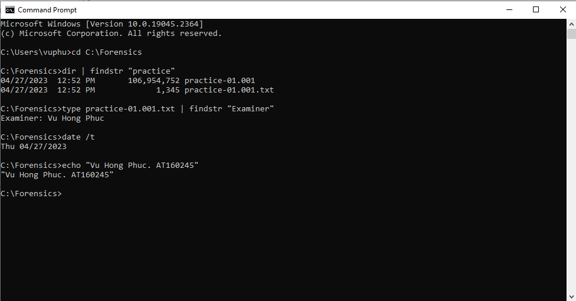

# LAB 5

**Select file**

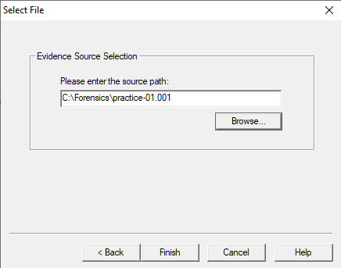

**View deleted file(s) in Recycle Bin**

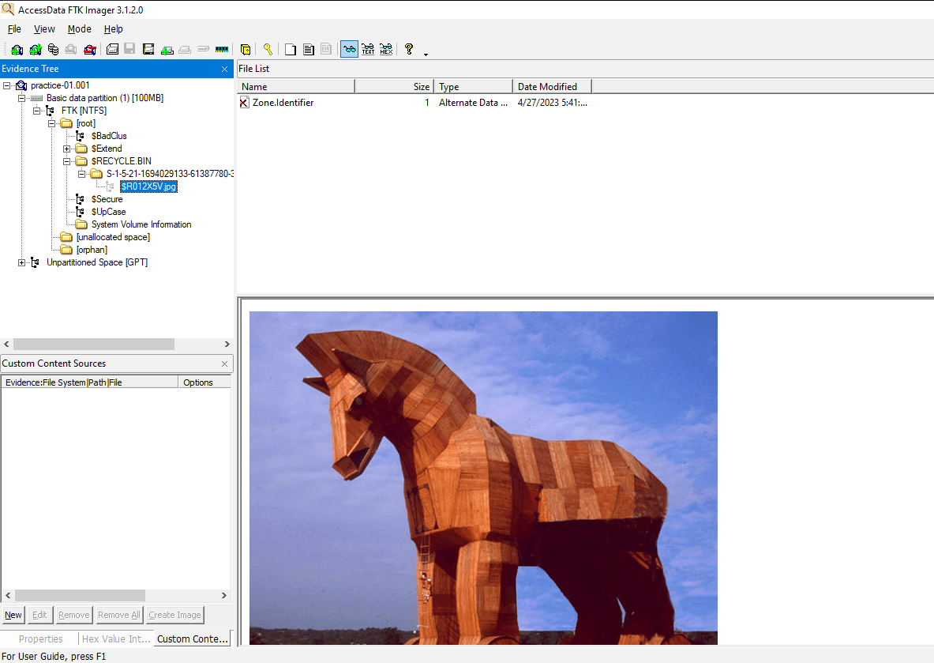

**View deleted file(s) in unallocated space**

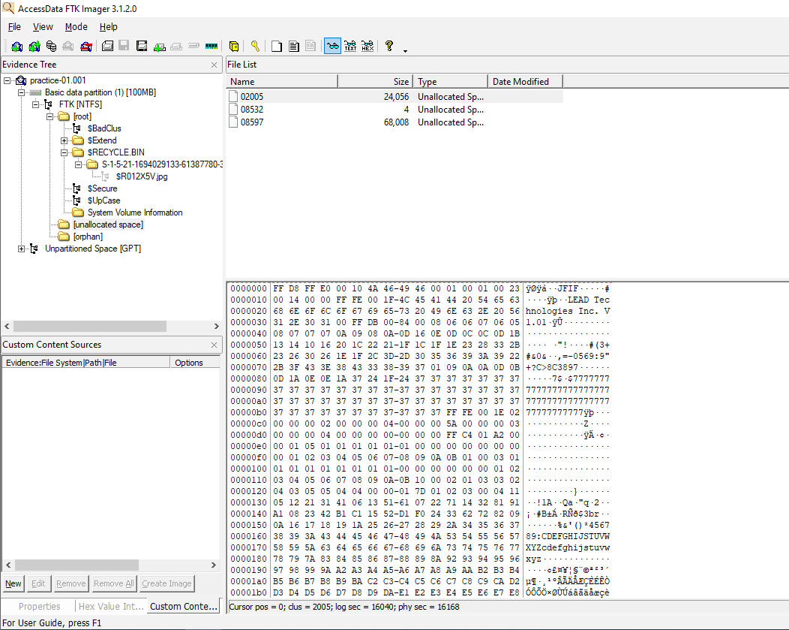

**Recover file and rename**

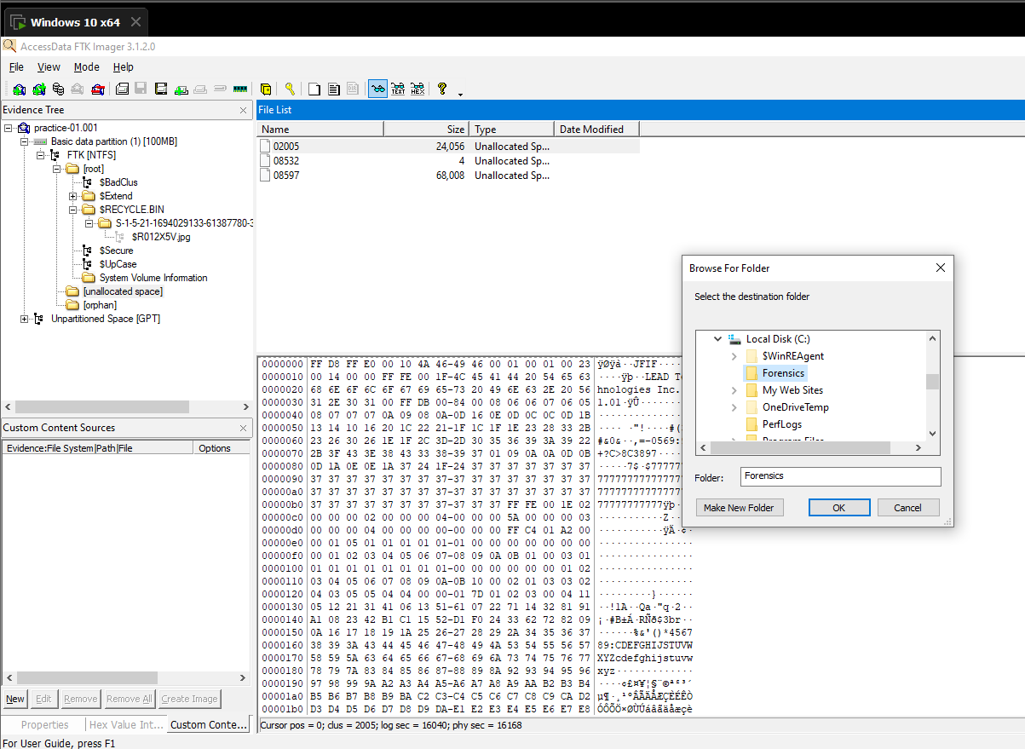 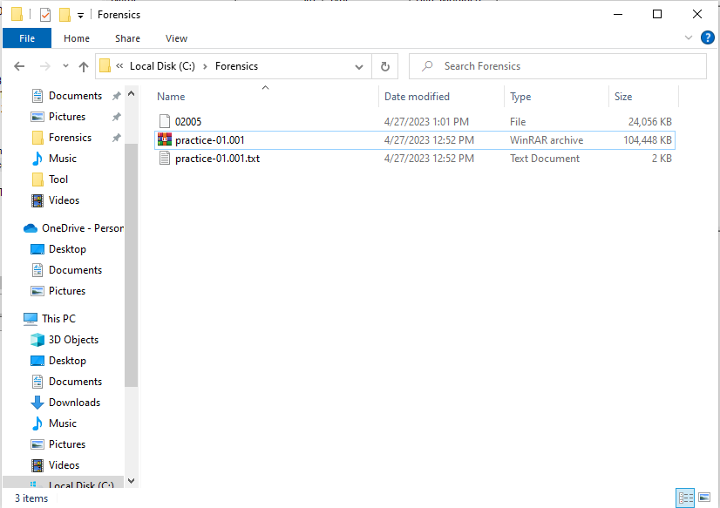

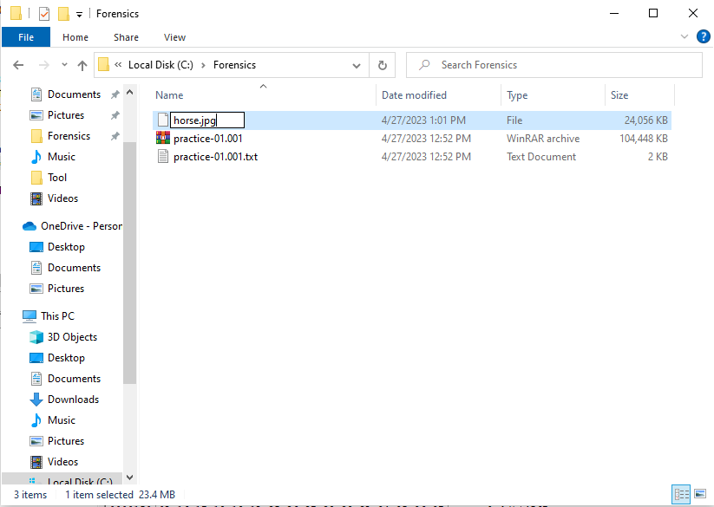

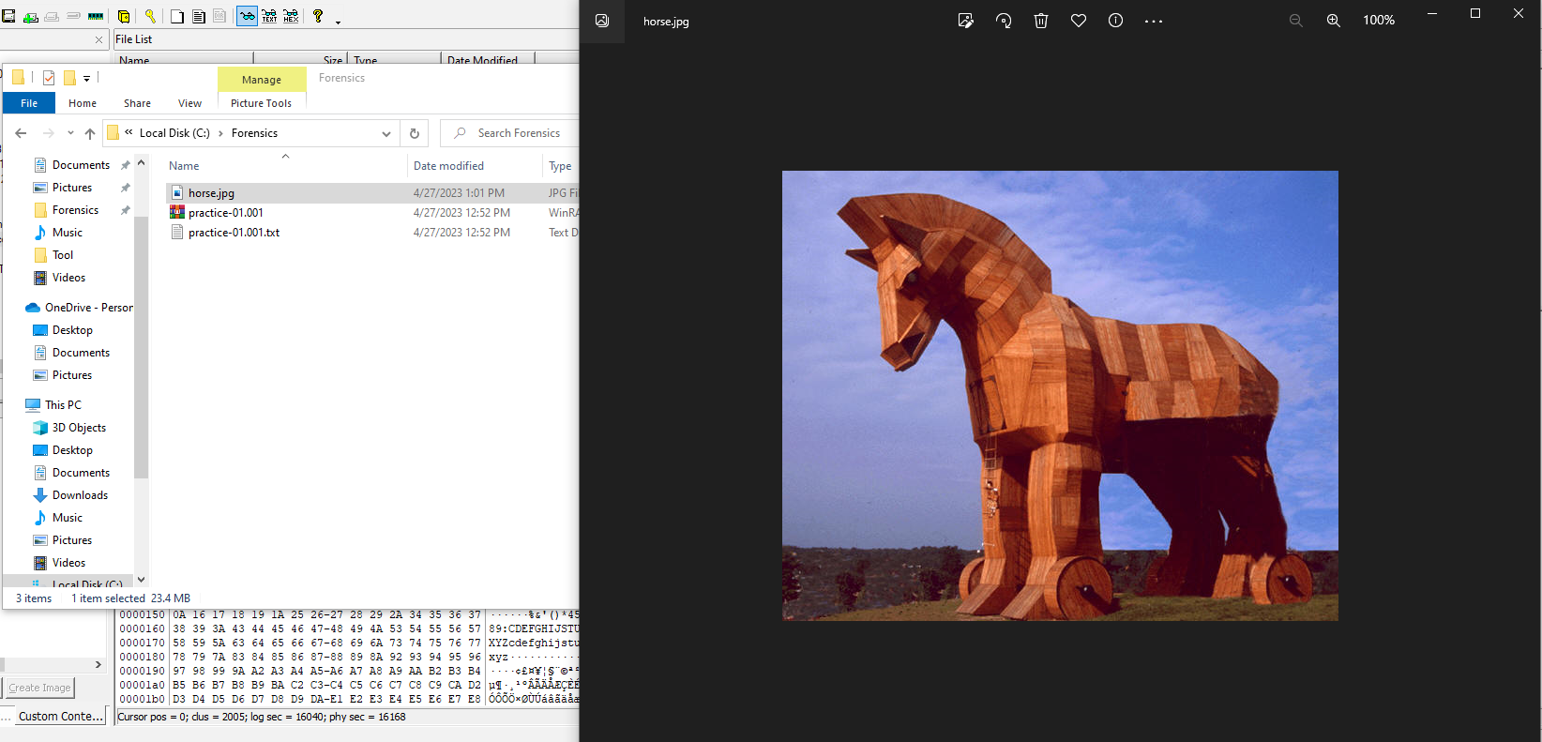

**Last 4 characters: 0c22**

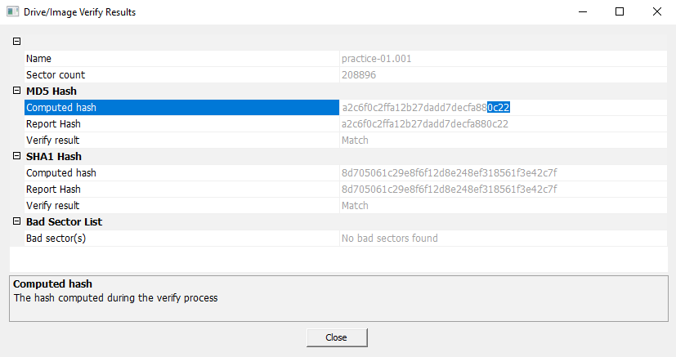

**Prof**

